NAME | Eli Soroño
PROJECT TITLE | ProqrLi: Web-Based Procurement and Vendor Management System
SUBJECT:  CODE:  TIME: | IT15/L Integrative Programming and Technologies
TOPIC (Type of Business Process) | #27 Procurement & Vendor Management System (PVMS)
Products/Services | Manufacturing & Procurement Firm
Tools Needed: | Visual Studio 2026, ASP.NET Core 8 (Web API), React.js with Tailwind CSS, Microsoft SQL Server (SSMS), Entity Framework Core, Azure App Service or Monsterasp.net, GitHub
Technology: | SAP Business One API, PayMongo API, Stripe API, SendGrid API, Random Forest, SignalR, Chart.js / Recharts
Security Features | JWT Authentication & Role-Based Authorization, Input Validation & Parameterized Queries (SQL Injection / XSS Prevention), HTTPS / SSL Enforcement, Audit Trail Logging with Timestamp & User Identity, Two-Factor Authentication (2FA) for Admin & Approver Accounts, Session Timeout & Token Expiry
Target user/s: | Procurement Officers, Plant / Operations Managers, Warehouse / Inventory Staff, Finance & Accounting Department, Vendor / Supplier Representatives (External Portal), System Administrator
Subs System / Management Transaction/Modules | - Vendor Accreditation  - Purchase Requisition & Approval  - Supplier Evaluation  - Contract & Pricing Management  - Procurement Analytics  - Invoice & Payment Processing Module  - Delivery & Logistics Tracking  - Inventory & Stock Monitoring  - Compliance & Document Management  - Subscription & Tenant Management (SaaS)
LOGO | 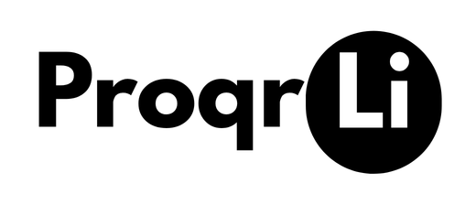
Project Objectives: | 1. To design and develop a cloud-based SaaS procurement platform that serves industrial enterprises in managing their vendor and purchasing operations efficiently within one semester.  2. To deliver a scalable and multi-tenant system architecture that allows multiple industrial organizations to subscribe and independently operate their procurement workflows under a single deployed platform.  3. To apply a supervised machine learning model that enables automated vendor risk assessment, supporting organizations in making data-driven procurement decisions.  4. To produce a system that improves operational transparency and accountability across all procurement activities through role-based access and real-time monitoring.  5. To ensure the platform meets enterprise-grade security and compliance standards suitable for industrial-scale procurement environments.
Project Description: | ProqrLi is designed for medium to large-scale industrial companies in manufacturing, construction, and heavy equipment sectors where procurement involves high-volume transactions, multiple vendors, and strict regulatory compliance. Primary users are Procurement Officers and Plant Managers who require a centralized platform to manage supplier relationships, purchasing workflows, and vendor risk.  By replacing spreadsheet-based manual procurement processes with an integrated digital platform, ProqrLi aims to reduce procurement cycle times, minimize approval bottlenecks, and proactively flag high-risk vendors before contract award protecting the organization from supply chain disruptions, financial losses, and compliance violations. The Random Forest ML module enables data-driven vendor risk decisions instead of relying solely on subjective evaluations.  ProqrLi is built on a full-stack ASP.NET Core 8 Web API + React.js architecture. The backend exposes RESTful APIs consumed by the React frontend, with Microsoft SQL Server as the relational database and Entity Framework Core as the ORM. SignalR handles real-time PO status tracking. The Random Forest model is developed using Python (scikit-learn) deployed as a microservice API, trained on vendor performance features such as on-time delivery rate, defect/rejection rate, price variance, compliance violations, and contract fulfillment rate.  ASP.NET Core 8 was chosen for its enterprise-grade performance and security capabilities. React.js provides a responsive, component-based frontend ideal for complex dashboards. Random Forest was selected over KNN for vendor risk detection because it handles class imbalance (few high-risk vendors vs. many low-risk ones), provides feature importance scores for audit reporting, and delivers higher accuracy on tabular structured data making it the industry-standard choice for supply chain risk classification systems.
Use Case Diagram  (Role-Based Access) | 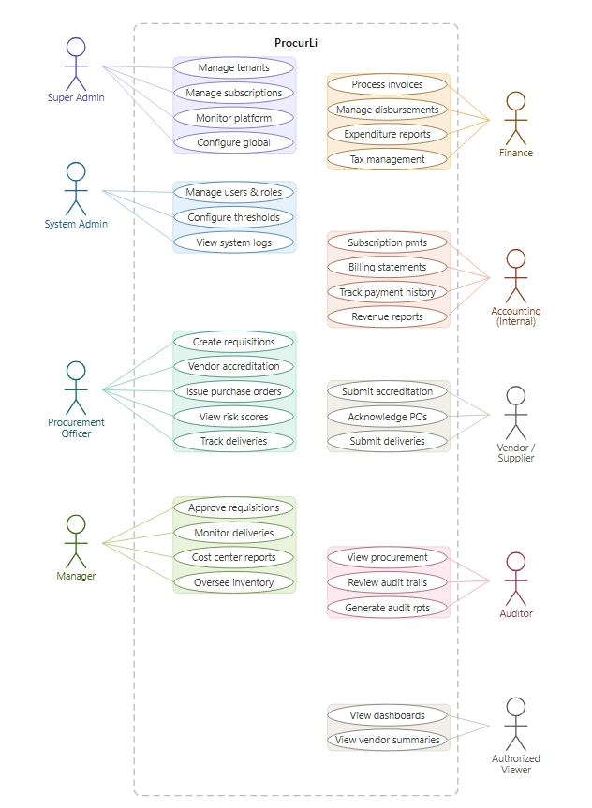  Role-Based Access for Industrial Procurement & Vendor Management System  Super Admin  - Oversee and manage all tenant organizations on the platform  - Activate, suspend, or deactivate tenant accounts  - Manage subscription plans, tiers, and billing cycles  - Monitor platform-wide system health and performance  - Access all tenant data for support and compliance purposes  - Configure global system settings and platform updates  - View platform-level analytics and revenue reports  System Administrator  - Manage all user accounts, roles, and permissions within their tenant  - Configure system settings and approval thresholds  - Access all modules within the tenant organization  - View system logs and audit trails  Procurement Officer  - Create and submit purchase requisitions  - Manage vendor accreditation applications  - Issue and monitor purchase orders  - View vendor risk scores  - Track delivery and logistics status  Manager  - Review and approve or reject purchase requisitions  - Monitor delivery schedules and material arrivals  - View procurement reports within their cost center  - Oversee inventory and stock levels  Finance  - Process invoice matching against approved Pos  - Manage payment disbursements  - Generate expenditure and cost variance reports  - Manage tax and statutory deductions  Accounting (ProcurLi Internal)  - Manage and monitor all incoming subscription payments from tenants- Generate billing statements and subscription invoices  - Track payment history and outstanding balances per tenant  - Coordinate with Super Admin on subscription plan renewals and upgrades  - Generate revenue and financial reports for the platform  Auditor  - View all procurement records (read-only)  - Review audit trails and transaction logs  - Check compliance and policy adherence  - Generate compliance and risk assessment reports  Authorized Viewer  - View reports and dashboards  - Read-only access to procurement data  - View vendor summaries and spending overviews  - No create, edit, or delete permissions
Date Submitted: | March 30, 2026
Teacher’s Feedback | _________________________________________________________________  _________________________________________________________________  _________________________________________________________________  _________________________________________________________________  _________________________________________________________________  _________________________________________________________________  ________________________________ __________________________  Student’s Signature (after feedbacking) Teacher’s Signature

